**WEEK - 3**

**Spring Core and Maven**

**Mandatory**

**Exercise 1: Configuring a Basic Spring Application**

**Pom.xml**

<project xmlns="http://maven.apache.org/POM/4.0.0"

xmlns:xsi="http://www.w3.org/2001/XMLSchema-instance"

xsi:schemaLocation="http://maven.apache.org/POM/4.0.0

http://maven.apache.org/xsd/maven-4.0.0.xsd">

<modelVersion>4.0.0</modelVersion>

<groupId>com.library</groupId>

<artifactId>LibraryManagement</artifactId>

<version>0.0.1-SNAPSHOT</version>

<dependencies>

<!-- Spring Core -->

<dependency>

<groupId>org.springframework</groupId>

<artifactId>spring-context</artifactId>

<version>5.3.34</version>

</dependency>

</dependencies>

</project>

**applicationContext.xml**

<?xml version="1.0" encoding="UTF-8"?>

<beans xmlns="http://www.springframework.org/schema/beans"

xmlns:xsi="http://www.w3.org/2001/XMLSchema-instance"

xsi:schemaLocation="http://www.springframework.org/schema/beans

https://www.springframework.org/schema/beans/spring-beans.xsd">

<bean id="bookRepository" class="com.library.repository.BookRepository"/>

<bean id="bookService" class="com.library.service.BookService">

<property name="bookRepository" ref="bookRepository"/>

</bean>

</beans>

**BookRepository.java**

package com.library.repository;

public class BookRepository {

public void displayBooks() {

System.out.println("Fetching books from repository...");

}

}

**BookService.java**

package com.library.service;

import com.library.repository.BookRepository;

public class BookService {

private BookRepository bookRepository;

// Setter for dependency injection

public void setBookRepository(BookRepository bookRepository) {

this.bookRepository = bookRepository;

}

public void showBooks() {

bookRepository.displayBooks();

}

}

**MainApp.java**

package com.library.main;

import org.springframework.context.ApplicationContext;

import org.springframework.context.support.ClassPathXmlApplicationContext;

import com.library.service.BookService;

public class MainApp {

public static void main(String[] args) {

ApplicationContext context = new ClassPathXmlApplicationContext("applicationContext.xml");

BookService bookService = (BookService) context.getBean("bookService");

bookService.showBooks();

((ClassPathXmlApplicationContext) context).close();

}

}

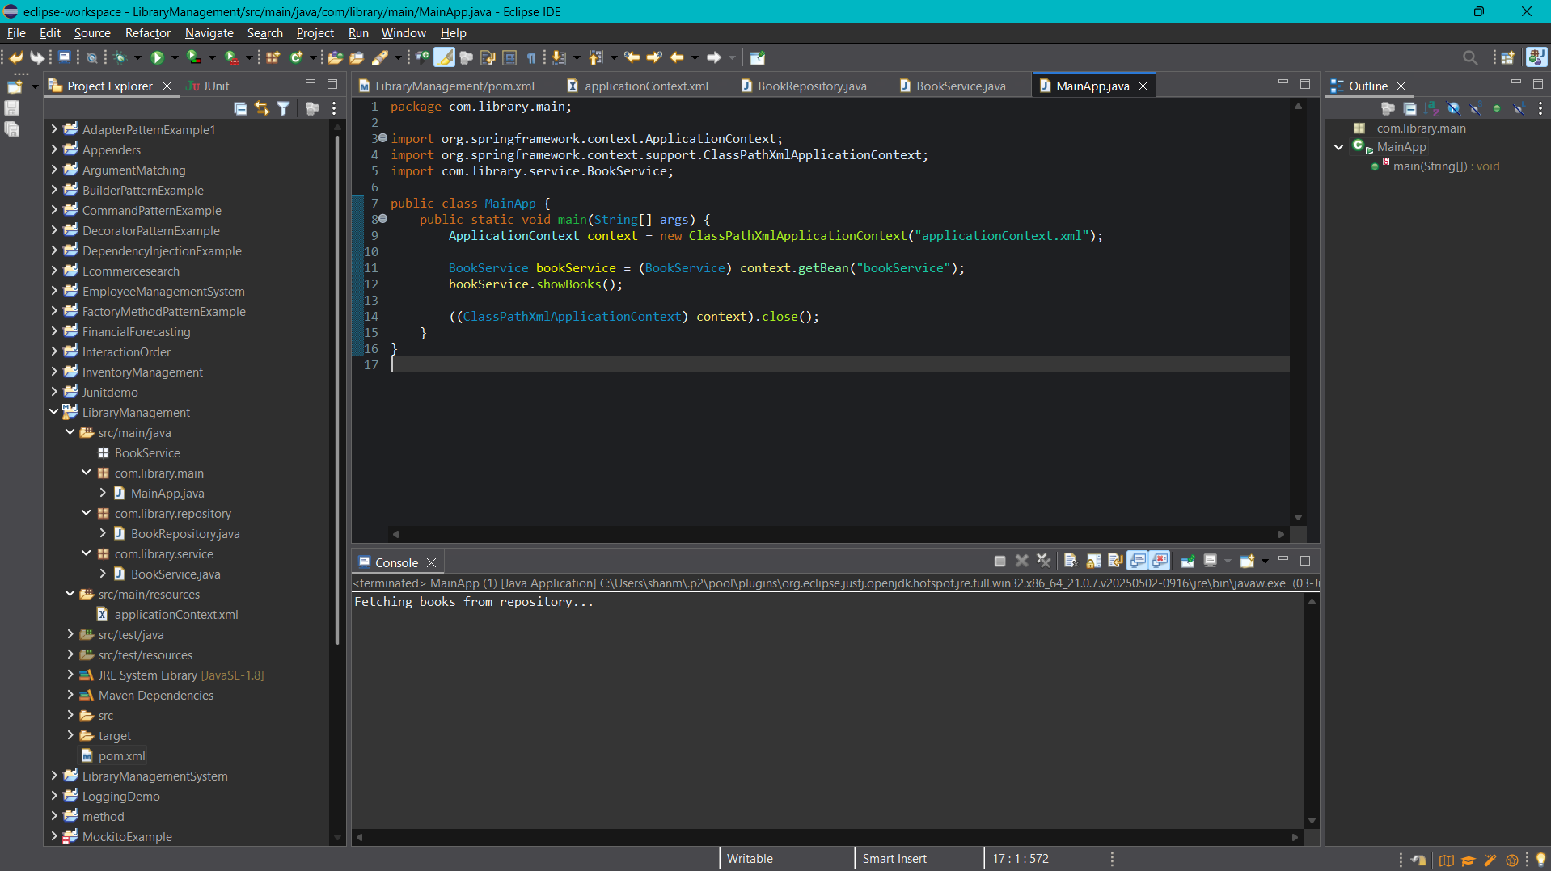

**Exercise 2: Implementing Dependency Injection**

**Pom.xml**

<project xmlns="http://maven.apache.org/POM/4.0.0"

xmlns:xsi="http://www.w3.org/2001/XMLSchema-instance"

xsi:schemaLocation="http://maven.apache.org/POM/4.0.0

http://maven.apache.org/xsd/maven-4.0.0.xsd">

<modelVersion>4.0.0</modelVersion>

<groupId>com.library</groupId>

<artifactId>LibraryManagement</artifactId>

<version>0.0.1-SNAPSHOT</version>

<dependencies>

<!-- Spring Core Context -->

<dependency>

<groupId>org.springframework</groupId>

<artifactId>spring-context</artifactId>

<version>5.3.34</version>

</dependency>

</dependencies>

</project>

**applicationContext.xml**

<?xml version="1.0" encoding="UTF-8"?>

<beans xmlns="http://www.springframework.org/schema/beans"

xmlns:xsi="http://www.w3.org/2001/XMLSchema-instance"

xsi:schemaLocation="http://www.springframework.org/schema/beans

https://www.springframework.org/schema/beans/spring-beans.xsd">

<bean id="bookRepository" class="com.library.repository.BookRepository"/>

<bean id="bookService" class="com.library.service.BookService">

<property name="bookRepository" ref="bookRepository"/>

</bean>

</beans>

**BookRepository.java**

package com.library.repository;

public class BookRepository {

public void displayBooks() {

System.out.println("Fetching books from BookRepository...");

}

}

**BookService.java**

package com.library.service;

import com.library.repository.BookRepository;

public class BookService {

private BookRepository bookRepository;

public void setBookRepository(BookRepository bookRepository) {

this.bookRepository = bookRepository;

}

public void showBooks() {

System.out.println("Inside BookService...");

bookRepository.displayBooks();

}

}

**MainApp.java**

package com.library.main;

import org.springframework.context.ApplicationContext;

import org.springframework.context.support.ClassPathXmlApplicationContext;

import com.library.service.BookService;

public class MainApp {

public static void main(String[] args) {

ApplicationContext context = new ClassPathXmlApplicationContext("applicationContext.xml");

BookService bookService = (BookService) context.getBean("bookService");

bookService.showBooks();

((ClassPathXmlApplicationContext) context).close();

}

}

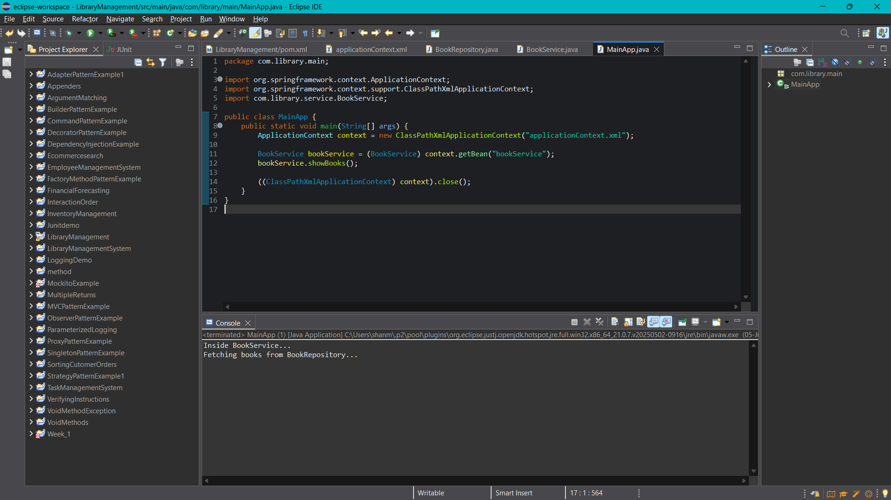

**Exercise 4: Creating and Configuring a Maven Project**

<project xmlns="http://maven.apache.org/POM/4.0.0"

xmlns:xsi="http://www.w3.org/2001/XMLSchema-instance"

xsi:schemaLocation="http://maven.apache.org/POM/4.0.0

http://maven.apache.org/xsd/maven-4.0.0.xsd">

<modelVersion>4.0.0</modelVersion>

<groupId>com.library</groupId>

<artifactId>LibraryManagement</artifactId>

<version>0.0.1-SNAPSHOT</version>

<dependencies>

<!-- Spring Core / Context -->

<dependency>

<groupId>org.springframework</groupId>

<artifactId>spring-context</artifactId>

<version>5.3.34</version>

</dependency>

<!-- Spring AOP -->

<dependency>

<groupId>org.springframework</groupId>

<artifactId>spring-aop</artifactId>

<version>5.3.34</version>

</dependency>

<!-- Spring Web MVC -->

<dependency>

<groupId>org.springframework</groupId>

<artifactId>spring-webmvc</artifactId>

<version>5.3.34</version>

</dependency>

<!-- Servlet API (required for Spring Web) -->

<dependency>

<groupId>javax.servlet</groupId>

<artifactId>javax.servlet-api</artifactId>

<version>4.0.1</version>

<scope>provided</scope>

</dependency>

</dependencies>

<!-- Maven Compiler Plugin -->

<build>

<plugins>

<plugin>

<artifactId>maven-compiler-plugin</artifactId>

<version>3.8.1</version>

<configuration>

<source>1.8</source>

<target>1.8</target>

</configuration>

</plugin>

</plugins>

</build>

</project>

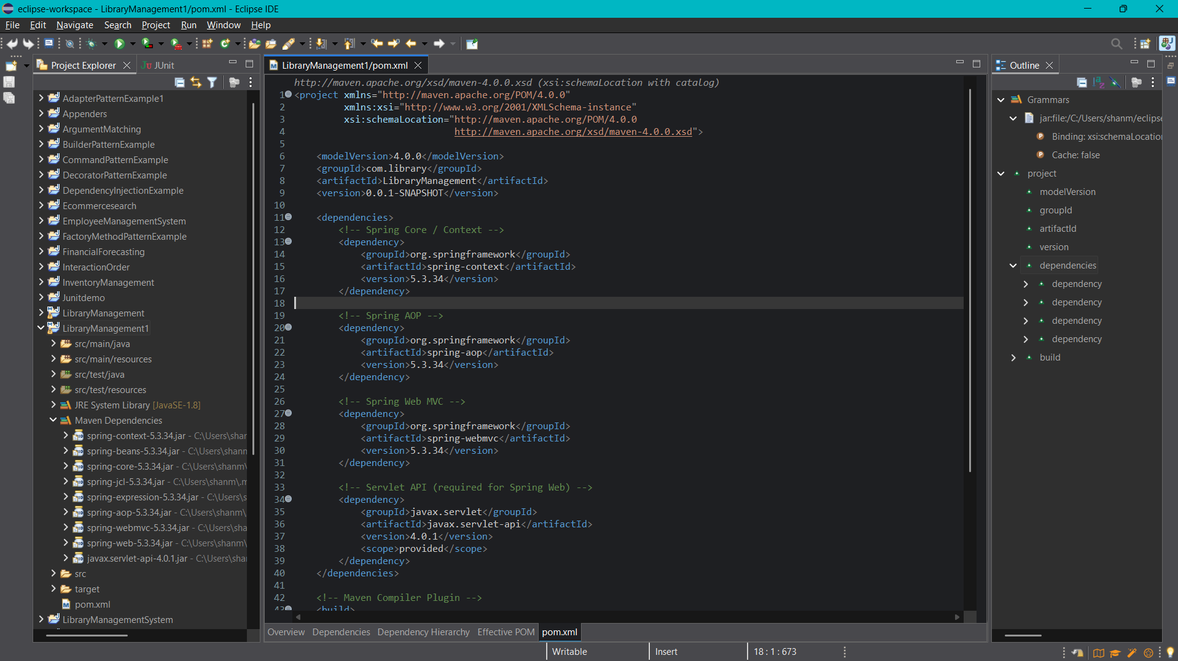

**Additional Important**

**Exercise 5: Configuring the Spring IoC Container**

**applicationContext.xml**

<?xml version="1.0" encoding="UTF-8"?>

<beans xmlns="http://www.springframework.org/schema/beans"

xmlns:xsi="http://www.w3.org/2001/XMLSchema-instance"

xsi:schemaLocation="

http://www.springframework.org/schema/beans

https://www.springframework.org/schema/beans/spring-beans.xsd">

<!-- Define BookRepository Bean -->

<bean id="bookRepository" class="com.library.repository.BookRepository" />

<!-- Define BookService Bean and inject BookRepository -->

<bean id="bookService" class="com.library.service.BookService">

<property name="bookRepository" ref="bookRepository" />

</bean>

</beans>

**BookRepository.java**

package com.library.repository;

public class BookRepository {

public String getBookData() {

return "Spring in Action by Craig Walls";

}

}

**BookService.java**

package com.library.service;

import com.library.repository.BookRepository;

public class BookService {

private BookRepository bookRepository;

public void setBookRepository(BookRepository bookRepository) {

this.bookRepository = bookRepository;

}

public void displayBook() {

System.out.println("Book: " + bookRepository.getBookData());

}

}

**LibraryManagementApp.java**

package com.library.library;

import org.springframework.context.ApplicationContext;

import org.springframework.context.support.ClassPathXmlApplicationContext;

import com.library.service.BookService;

public class LibraryManagementApp {

public static void main(String[] args) {

@SuppressWarnings("resource")

ApplicationContext context = new ClassPathXmlApplicationContext("applicationContext.xml");

BookService bookService = (BookService) context.getBean("bookService");

bookService.displayBook();

}

}

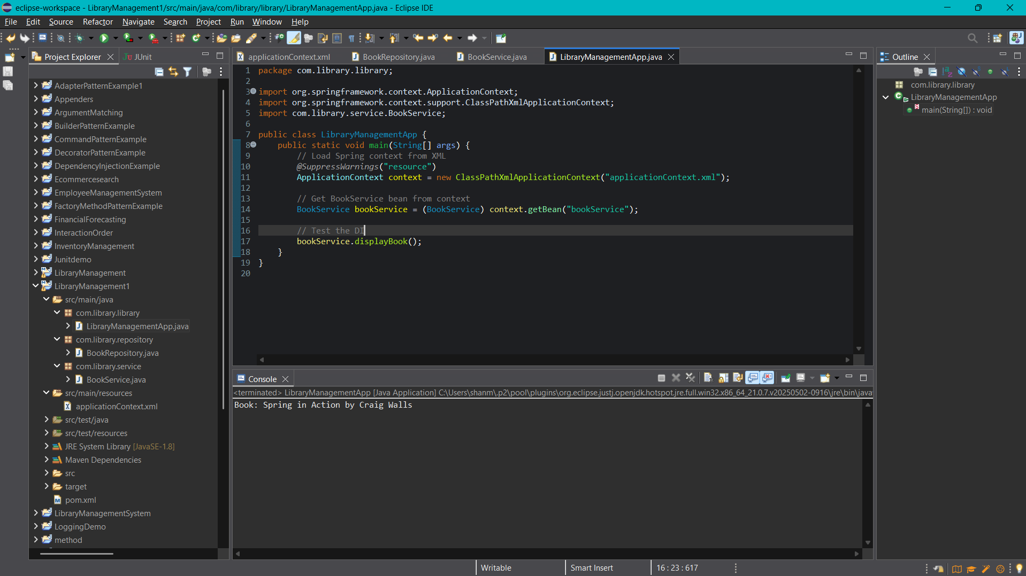

**Exercise 7: Implementing Constructor and Setter Injection**

**applicationContext.xml**

<?xml version="1.0" encoding="UTF-8"?>

<beans xmlns="http://www.springframework.org/schema/beans"

xmlns:xsi="http://www.w3.org/2001/XMLSchema-instance"

xsi:schemaLocation="

http://www.springframework.org/schema/beans

https://www.springframework.org/schema/beans/spring-beans.xsd">

<!-- BookRepository Bean -->

<bean id="bookRepository" class="com.library.repository.BookRepository" />

<!-- NotificationService Bean -->

<bean id="notificationService" class="com.library.service.NotificationService" />

<!-- BookService Bean with constructor and setter injection -->

<bean id="bookService" class="com.library.service.BookService">

<!-- Constructor Injection -->

<constructor-arg ref="notificationService" />

<!-- Setter Injection -->

<property name="bookRepository" ref="bookRepository" />

</bean>

</beans>

**BookRepository.java**

package com.library.repository;

public class BookRepository {

public String getBookData() {

return "Spring in Action by Craig Walls";

}

}

**BookService.java**

package com.library.service;

import com.library.repository.BookRepository;

public class BookService {

private BookRepository bookRepository;

private NotificationService notificationService;

// Constructor Injection

public BookService(NotificationService notificationService) {

this.notificationService = notificationService;

}

// Setter Injection

public void setBookRepository(BookRepository bookRepository) {

this.bookRepository = bookRepository;

}

public void displayBook() {

String book = bookRepository.getBookData();

System.out.println("Book: " + book);

notificationService.sendNotification("Book fetched successfully.");

}

}

**NotificationService.java**

package com.library.service;

public class NotificationService {

public void sendNotification(String message) {

System.out.println("Notification: " + message);

}

}

**LibraryManagementApp.java**

package com.library.library;

import org.springframework.context.ApplicationContext;

import org.springframework.context.support.ClassPathXmlApplicationContext;

import com.library.service.BookService;

public class LibraryManagementApp {

@SuppressWarnings("resource")

public static void main(String[] args) {

ApplicationContext context = new ClassPathXmlApplicationContext("applicationContext.xml");

BookService bookService = (BookService) context.getBean("bookService");

bookService.displayBook();

}

}

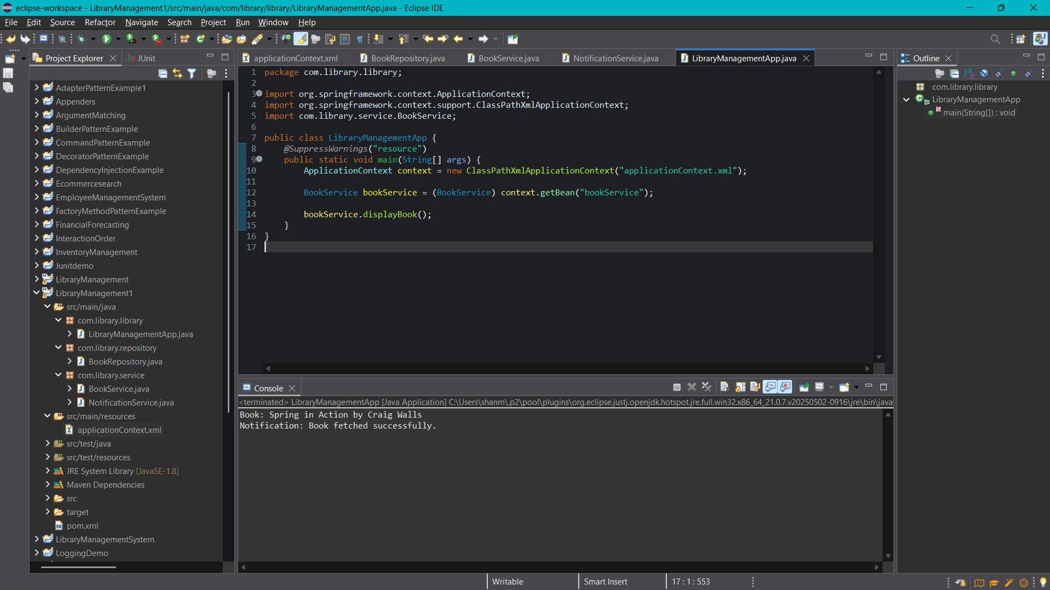

**Exercise 9: Creating a Spring Boot Application**

**apllication.properties**

spring.application.name=LibraryManagement

# Enable H2 Console

spring.h2.console.enabled=true

spring.h2.console.path=/h2-console

# Configure In-Memory H2 DB

spring.datasource.url=jdbc:h2:mem:librarydb

spring.datasource.driverClassName=org.h2.Driver

spring.datasource.username=sa

spring.datasource.password=

# JPA Settings

spring.jpa.database-platform=org.hibernate.dialect.H2Dialect

spring.jpa.hibernate.ddl-auto=update

**Book.java**

package com.library.entity;

import jakarta.persistence.*;

@Entity

public class Book {

@Id

@GeneratedValue(strategy = GenerationType.IDENTITY)

private Long id;

private String title;

private String author;

public Book() {}

public Book(String title, String author) {

this.title = title;

this.author = author;

}

// Getters and Setters

public Long getId() { return id; }

public void setId(Long id) { this.id = id; }

public String getTitle() { return title; }

public void setTitle(String title) { this.title = title; }

public String getAuthor() { return author; }

public void setAuthor(String author) { this.author = author; }

}

**BookRepository.java**

package com.library.repository;

import com.library.entity.Book;

import org.springframework.data.jpa.repository.JpaRepository;

public interface BookRepository extends JpaRepository<Book, Long> {

}

**BookController.java**

package com.library.controller;

import com.library.entity.Book;

import com.library.repository.BookRepository;

import org.springframework.beans.factory.annotation.Autowired;

import org.springframework.web.bind.annotation.*;

import java.util.List;

@RestController

@RequestMapping("/api/books")

public class BookController {

@Autowired

private BookRepository bookRepository;

@GetMapping

public List<Book> getAllBooks() {

return bookRepository.findAll();

}

@PostMapping

public Book addBook(@RequestBody Book book) {

return bookRepository.save(book);

}

@GetMapping("/{id}")

public Book getBookById(@PathVariable Long id) {

return bookRepository.findById(id).orElse(null);

}

@PutMapping("/{id}")

public Book updateBook(@PathVariable Long id, @RequestBody Book updatedBook) {

Book book = bookRepository.findById(id).orElse(null);

if (book != null) {

book.setTitle(updatedBook.getTitle());

book.setAuthor(updatedBook.getAuthor());

return bookRepository.save(book);

}

return null;

}

@DeleteMapping("/{id}")

public void deleteBook(@PathVariable Long id) {

bookRepository.deleteById(id);

}

}

**LibraryManagementApplication.java**

package com.library;

import org.springframework.boot.SpringApplication;

import org.springframework.boot.autoconfigure.SpringBootApplication;

@SpringBootApplication

public class LibraryManagementApplication {

public static void main(String[] args) {

SpringApplication.run(LibraryManagementApplication.class, args);

}

}

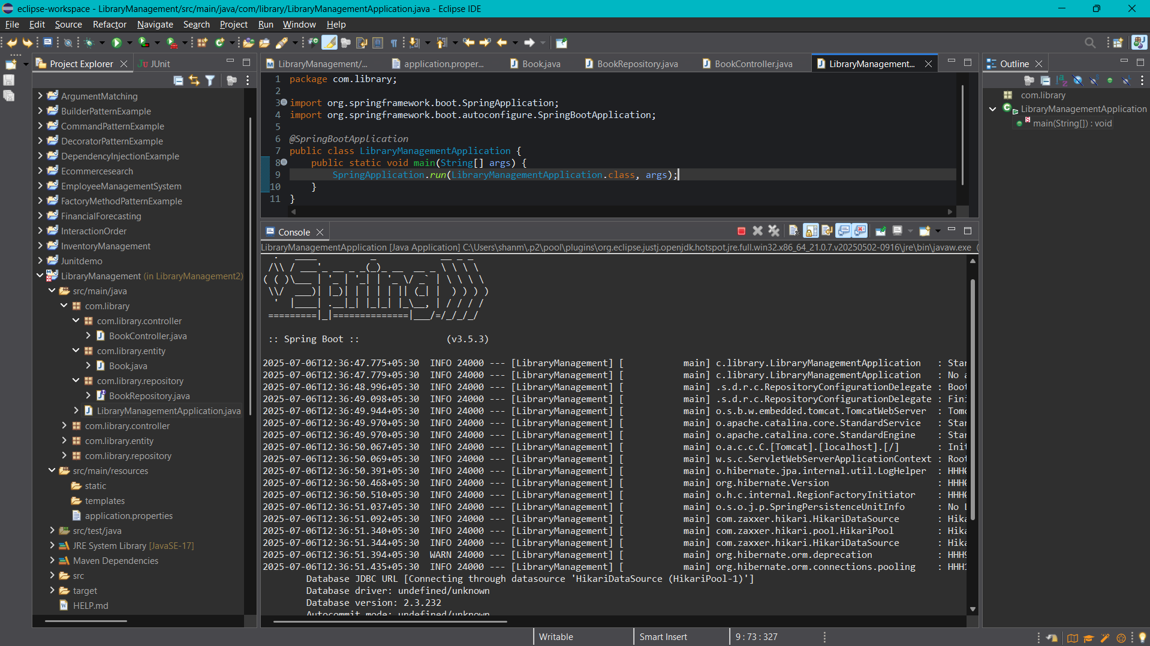

**Additional**

**Exercise 3: Implementing Logging with Spring AOP**

**Pom.xml**

<project xmlns="http://maven.apache.org/POM/4.0.0"

xmlns:xsi="http://www.w3.org/2001/XMLSchema-instance"

xsi:schemaLocation="http://maven.apache.org/POM/4.0.0

http://maven.apache.org/xsd/maven-4.0.0.xsd">

<modelVersion>4.0.0</modelVersion>

<groupId>com.library</groupId>

<artifactId>library-management</artifactId>

<version>1.0</version>

<dependencies>

<!-- Spring Context -->

<dependency>

<groupId>org.springframework</groupId>

<artifactId>spring-context</artifactId>

<version>5.3.34</version>

</dependency>

<!-- Spring AOP -->

<dependency>

<groupId>org.springframework</groupId>

<artifactId>spring-aspects</artifactId>

<version>5.3.34</version>

</dependency>

<!-- AspectJ -->

<dependency>

<groupId>org.aspectj</groupId>

<artifactId>aspectjweaver</artifactId>

<version>1.9.21</version>

</dependency>

</dependencies>

</project>

**BookService.java**

package com.library.service;

import org.springframework.stereotype.Component;

@Component

public class BookService {

public void getAllBooks() {

System.out.println("Fetching all books from the library...");

try {

Thread.sleep(500); // Simulate a delay

} catch (InterruptedException e) {

e.printStackTrace();

}

}

}

**LoggingAspect.java**

package com.library.aspect;

import org.aspectj.lang.ProceedingJoinPoint;

import org.aspectj.lang.annotation.Around;

import org.aspectj.lang.annotation.Aspect;

import org.springframework.stereotype.Component;

@Aspect

@Component

public class LoggingAspect {

@Around("execution(* com.library.service.*.*(..))")

public Object logExecutionTime(ProceedingJoinPoint joinPoint) throws Throwable {

long start = System.currentTimeMillis();

Object result = joinPoint.proceed(); // actual method execution

long timeTaken = System.currentTimeMillis() - start;

System.out.println("Execution time of " + joinPoint.getSignature() + " :: " + timeTaken + " ms");

return result;

}

}

**applicationContext.xml**

<?xml version="1.0" encoding="UTF-8"?>

<beans xmlns="http://www.springframework.org/schema/beans"

xmlns:xsi="http://www.w3.org/2001/XMLSchema-instance"

xmlns:context="http://www.springframework.org/schema/context"

xmlns:aop="http://www.springframework.org/schema/aop"

xsi:schemaLocation="

http://www.springframework.org/schema/beans http://www.springframework.org/schema/beans/spring-beans.xsd

http://www.springframework.org/schema/context http://www.springframework.org/schema/context/spring-context.xsd

http://www.springframework.org/schema/aop http://www.springframework.org/schema/aop/spring-aop.xsd">

<!-- Enable component scanning -->

<context:component-scan base-package="com.library"/>

<!-- Enable AspectJ support -->

<aop:aspectj-autoproxy/>

</beans>

**LibraryManagementApplication.java**

package com.library;

import com.library.service.BookService;

import org.springframework.context.ApplicationContext;

import org.springframework.context.support.ClassPathXmlApplicationContext;

public class LibraryManagementApplication {

public static void main(String[] args) {

ApplicationContext context = new ClassPathXmlApplicationContext("com/library/config/applicationContext.xml");

BookService bookService = context.getBean(BookService.class);

bookService.getAllBooks(); // Trigger aspect

}

}

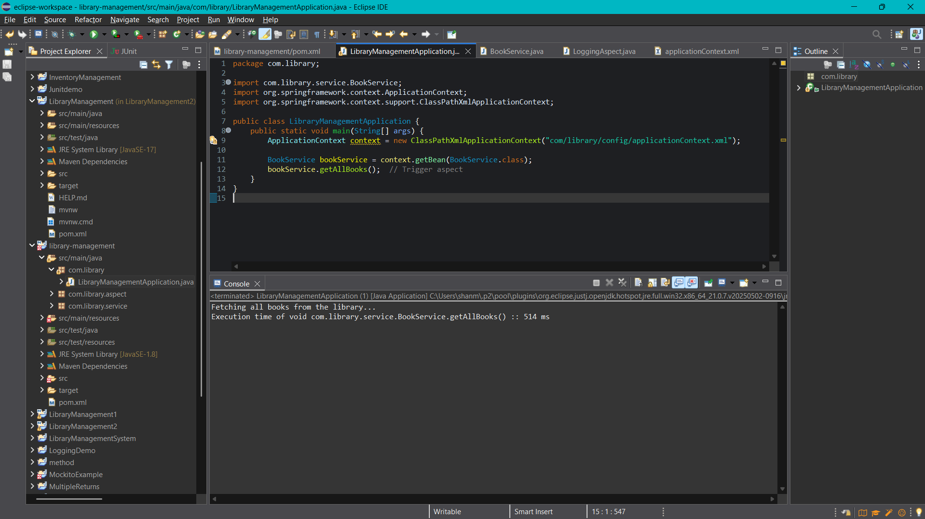

**Exercise 6: Configuring Beans with Annotations**

**pom.xml**

<project xmlns="http://maven.apache.org/POM/4.0.0" xmlns:xsi="http://www.w3.org/2001/XMLSchema-instance" xsi:schemaLocation="http://maven.apache.org/POM/4.0.0 https://maven.apache.org/xsd/maven-4.0.0.xsd">

<modelVersion>4.0.0</modelVersion>

<groupId>com.library</groupId>

<artifactId>LibraryManagement3</artifactId>

<version>0.0.1-SNAPSHOT</version>

<dependencies>

<!-- Spring Context -->

<dependency>

<groupId>org.springframework</groupId>

<artifactId>spring-context</artifactId>

<version>5.3.33</version> <!-- Use version appropriate for your setup -->

</dependency>

<!-- Spring AOP (if used) -->

<dependency>

<groupId>org.springframework</groupId>

<artifactId>spring-aspects</artifactId>

<version>5.3.33</version>

</dependency>

</dependencies>

</project>

**applicationContext.xml**

<?xml version="1.0" encoding="UTF-8"?>

<beans xmlns="http://www.springframework.org/schema/beans"

xmlns:xsi="http://www.w3.org/2001/XMLSchema-instance"

xmlns:context="http://www.springframework.org/schema/context"

xmlns:aop="http://www.springframework.org/schema/aop"

xsi:schemaLocation="

http://www.springframework.org/schema/beans http://www.springframework.org/schema/beans/spring-beans.xsd

http://www.springframework.org/schema/context http://www.springframework.org/schema/context/spring-context.xsd

http://www.springframework.org/schema/aop http://www.springframework.org/schema/aop/spring-aop.xsd">

<!-- Scan for @Service, @Repository, etc. -->

<context:component-scan base-package="com.library"/>

<!-- Enable AOP -->

<aop:aspectj-autoproxy/>

</beans>

**BookService.java**

package com.library.service;

import com.library.repository.BookRepository;

import org.springframework.beans.factory.annotation.Autowired;

import org.springframework.stereotype.Service;

@Service

public class BookService {

@Autowired

private BookRepository bookRepository;

public void displayBooks() {

System.out.println("Service: Displaying books");

bookRepository.fetchBooks();

}

}

**BookRepository.java**

package com.library.repository;

import org.springframework.stereotype.Repository;

@Repository

public class BookRepository {

public void fetchBooks() {

System.out.println("Repository: Fetching books from DB...");

}

}

**LibraryManagementApllication.java**

package com.library;

import com.library.service.BookService;

import org.springframework.context.ApplicationContext;

import org.springframework.context.support.ClassPathXmlApplicationContext;

public class LibraryManagementApllication {

public static void main(String[] args) {

ApplicationContext context =

new ClassPathXmlApplicationContext("com/library/config/applicationContext.xml");

BookService service = context.getBean(BookService.class);

service.displayBooks();

}

}

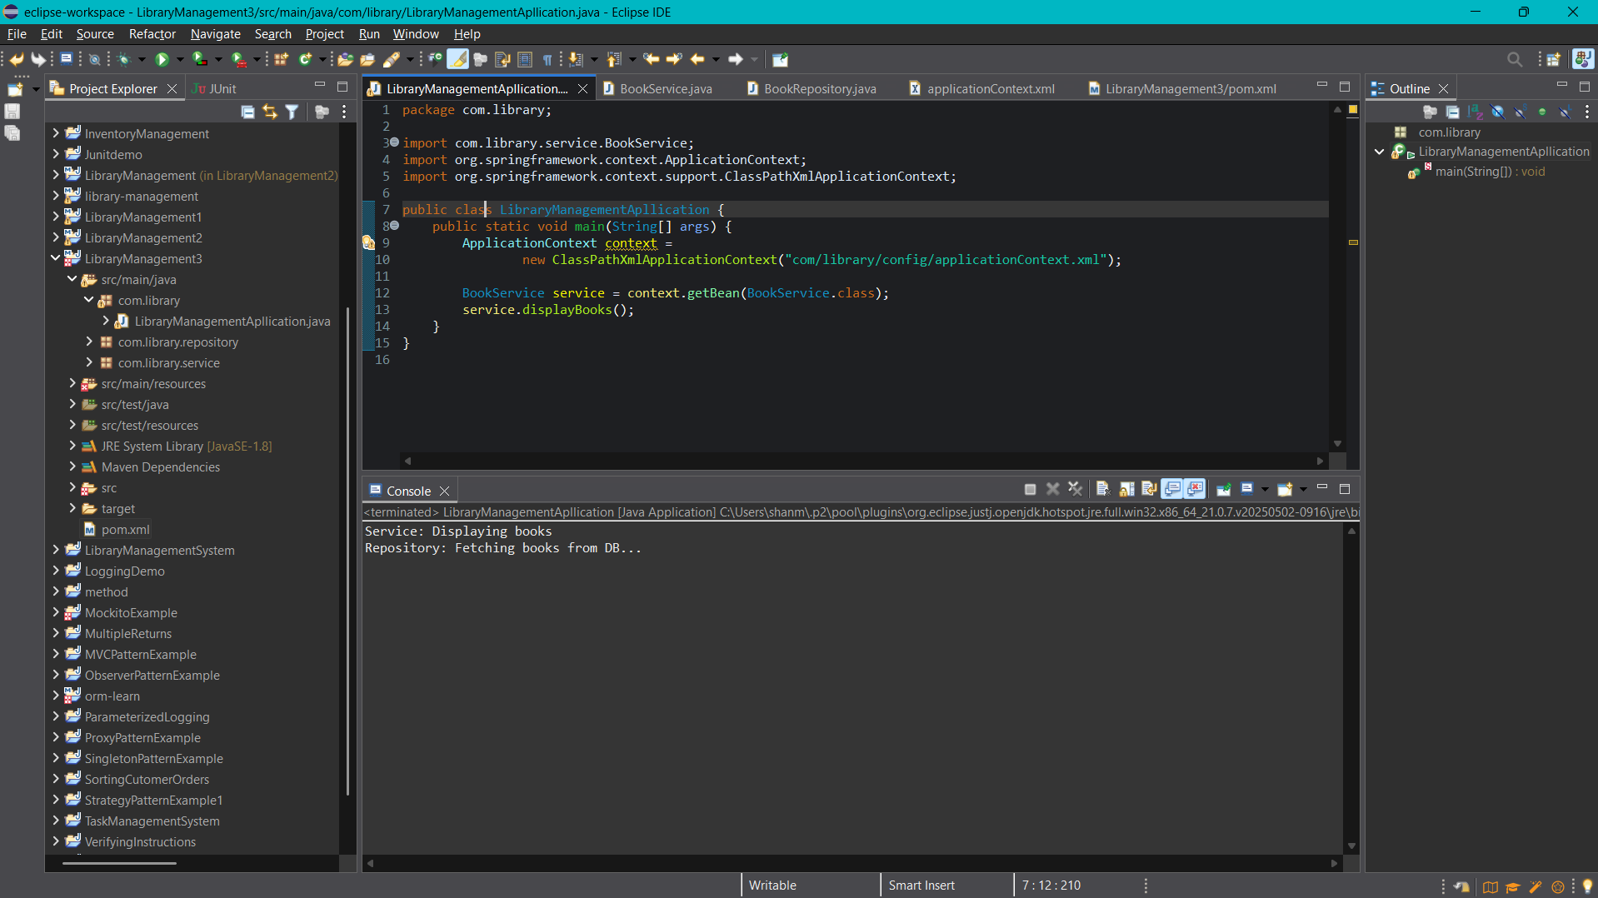

**Exercise 8: Implementing Basic AOP with Spring**

**Pom.xml**

<project xmlns="http://maven.apache.org/POM/4.0.0" xmlns:xsi="http://www.w3.org/2001/XMLSchema-instance" xsi:schemaLocation="http://maven.apache.org/POM/4.0.0 https://maven.apache.org/xsd/maven-4.0.0.xsd">

<modelVersion>4.0.0</modelVersion>

<groupId>com.library</groupId>

<artifactId>LibraryManagement4</artifactId>

<version>0.0.1-SNAPSHOT</version>

<dependencies>

<!-- Spring Core & Context -->

<dependency>

<groupId>org.springframework</groupId>

<artifactId>spring-context</artifactId>

<version>5.3.33</version>

</dependency>

<!-- Spring AOP -->

<dependency>

<groupId>org.springframework</groupId>

<artifactId>spring-aspects</artifactId>

<version>5.3.33</version>

</dependency>

</dependencies>

</project>

**applicationContext.java**

<?xml version="1.0" encoding="UTF-8"?>

<beans xmlns="http://www.springframework.org/schema/beans"

xmlns:xsi="http://www.w3.org/2001/XMLSchema-instance"

xmlns:context="http://www.springframework.org/schema/context"

xmlns:aop="http://www.springframework.org/schema/aop"

xsi:schemaLocation="

http://www.springframework.org/schema/beans http://www.springframework.org/schema/beans/spring-beans.xsd

http://www.springframework.org/schema/context http://www.springframework.org/schema/context/spring-context.xsd

http://www.springframework.org/schema/aop http://www.springframework.org/schema/aop/spring-aop.xsd">

<context:component-scan base-package="com.library"/>

<aop:aspectj-autoproxy/>

</beans>

**BookService.java**

package com.library.service;

import org.springframework.stereotype.Service;

@Service

public class BookService {

public void displayBooks() {

System.out.println("📚 Displaying list of books...");

}

}

**LoggingAspect.java**

package com.library.aspect;

import org.aspectj.lang.annotation.After;

import org.aspectj.lang.annotation.Aspect;

import org.aspectj.lang.annotation.Before;

import org.springframework.stereotype.Component;

@Aspect

@Component

public class LoggingAspect {

@Before("execution(* com.library.service.*.*(..))")

public void beforeMethod() {

System.out.println("🔍 [Before] Method is about to execute...");

}

@After("execution(* com.library.service.*.*(..))")

public void afterMethod() {

System.out.println("✅ [After] Method has executed.");

}

}

**LibraryManagementApllication.java**

package com.library;

import com.library.service.BookService;

import org.springframework.context.ApplicationContext;

import org.springframework.context.support.ClassPathXmlApplicationContext;

public class LibraryManagementApplication {

public static void main(String[] args) {

ApplicationContext context =

new ClassPathXmlApplicationContext("com/library/config/applicationContext.xml");

BookService service = context.getBean(BookService.class);

service.displayBooks();

}

}

